**Pengantar Python, Pandas, NumPy dan Visualisasi**

Tujuan

Memahami tentang dasar pemreograman, pengolahan data dan visualisasi pada python

**Instalasi package**

* Install package python yang terdiri dari:

scipy: 0.19.1

numpy: 1.13.3

matplotlib: 2.1.0

pandas: 0.20.3

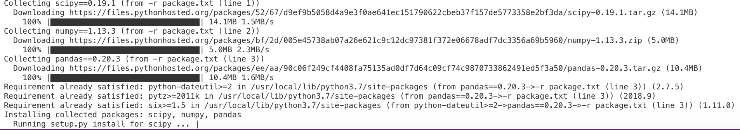

* Install terpisah

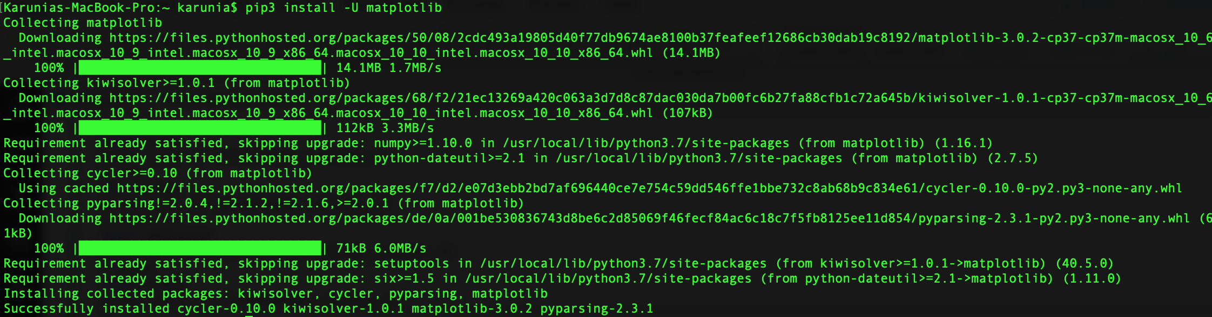



* Cek apakah package suda ada dengan menggunakan code berikut (cek_package.py)

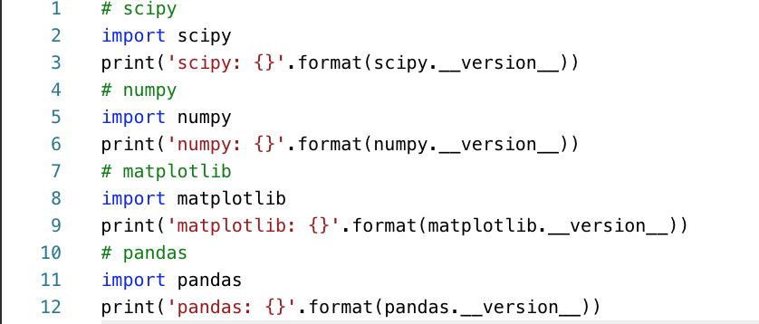

* Run Code:
* python cek_package.py (python 2)
* python3 cek_package.py (python 3)
* Jika belum terinstall package

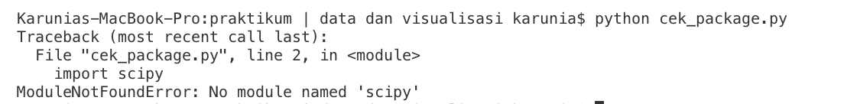

* Jika package sudah terinstall semua

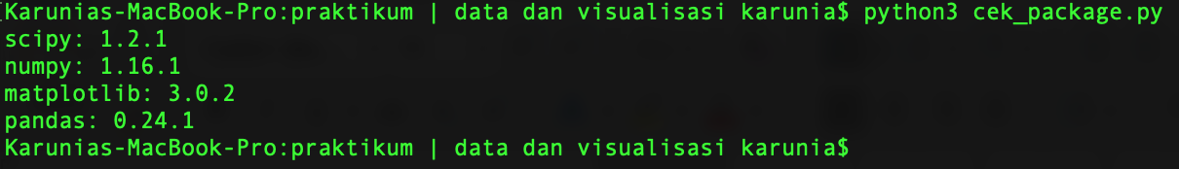

**Basic Python (Basic_Python.ipynb)**

* Assignment

|  |  |  |
| --- | --- | --- |
| String |  | h  11  hello world |
| Number |  | 123.1  10 |
| Boolean |  | (True, False) |
| Multiple Assignment |  | (1, 2, 3) |
| No value |  | None |

* Flow Control

|  |  |  |
| --- | --- | --- |
| If-Then-Else Conditional |  | That is fast |
| For-Loop |  | 0  1  2  3  4  5  6  7  8  9 |
| While-Loop |  | 0  1  2  3  4  5  6  7  8  9 |

* Data Structure

|  |  |  |
| --- | --- | --- |
| Tuples |  | (1, 2, 3) |
| List |  | Zeroth Value: 1  List Length: 4  1  2  3  4 |
| Directory |  | A value: 1  A value: 11  Keys: ['a', 'c', 'b']  Values: [11, 3, 2]  11  3  2 |
| Function |  | 4 |

**Tugas basic python (Basic_Python_Tugas.ipynb)**

<https://gist.github.com/achluky/275167464469c7e040e01fb6eb22be70>

**Pengolahan data pada python**

* **NumPy** menyediakan pengolahan data dalam data Structure Array. Numpy menyediakan scientific computing pada python. Numpy menyediakan libaray python untuk pengguna matlab.

|  |  |  |
| --- | --- | --- |
| Operasi pada Array |  | [1 2 3] #isi array  (3,) #tiga kolom 1 baris |
| Data type |  | int64  float64  int64 |
| Akses Data Array |  | [[1 2 3]  [3 4 5]]  (2, 3)  First row: [1 2 3]  Last row: [3 4 5]  Specific row and col: 3  Whole col: [3 5] |
|  |  | [[2 3]  [6 7]]  2  77 |
| Aritmatika |  | Addition: [5 5 5]  Multiplication: [6 6 6] |
|  |  | ? |
|  |  | ? |

Contoh penggunaan numpy pada aljabar linear (cabang matematika yang berkaitan dengan ruang vektor dan pemetaan antar ruang

Matrix determinant dan Matrix inverse

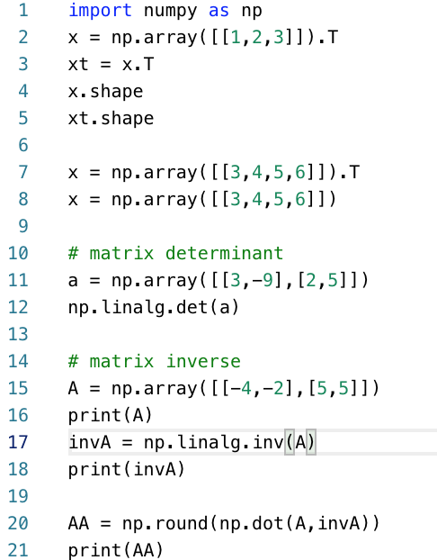

Eigenvalue dan eigenvector

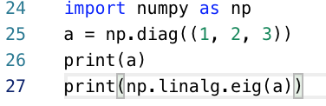

Sumber: <https://docs.scipy.org/doc/numpy/reference/index.html#reference>

Tugas Numpy:

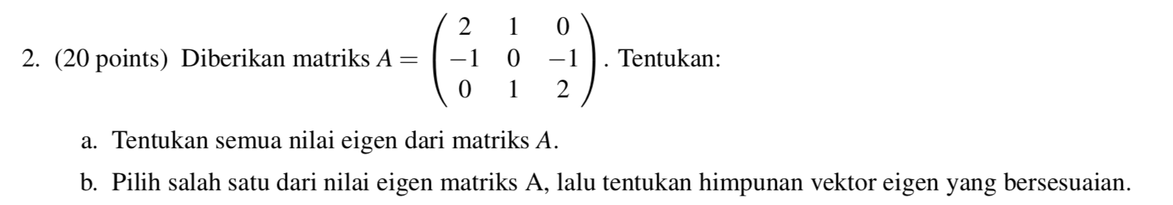

Buat program dengan menggunakan numpy untuk menyelesaikan soal di atas.

* **Pandas** provides **data structures and functionality** to quickly manipulate and analyze data

**Series:** Struktur data dengan 1 dimensi

|  |  |  |
| --- | --- | --- |
| Series |  | a 1  b 2  c 3  dtype: int64  1  1 |

# Data Frame: Struktur data dengan 2 dimensi

|  |  |  |
| --- | --- | --- |
| DataFrame from **Array** |  |  |
| DataFrame from **Directory** |  |  |
| DataFrame from **Llst** |  | ? |

# CSV File

**Structur CSV File**

|  |  |
| --- | --- |
| Comment | # |
| Delimiter | , |
| Quotes | “ / ‘ |

CSV file Example. Name File : “pima-indians-diabetes.data.csv”

|  |  |  |  |  |  |  |  |  |
| --- | --- | --- | --- | --- | --- | --- | --- | --- |
| 6 | 148 | 72 | 35 | 0 | 33.6 | 0.627 | 50 | 1 |
| 1 | 85 | 66 | 29 | 0 | 26.6 | 0.351 | 31 | 0 |
| 8 | 183 | 64 | 0 | 0 | 23.3 | 0.672 | 32 | 1 |
| 1 | 89 | 66 | 23 | 94 | 28.1 | 0.167 | 21 | 0 |
| 0 | 137 | 40 | 35 | 168 | 43.1 | 2.288 | 33 | 1 |
| 5 | 116 | 74 | 0 | 0 | 25.6 | 0.201 | 30 | 0 |

Source : <https://s.id/3yHRu> / <https://raw.githubusercontent.com/jbrownlee/Datasets/master/pima-indians-diabetes.data.csv>

**Python Standart Library**

|  |
| --- |
|  |

**Numpy**

|  |
| --- |
|  |

|  |
| --- |
|  |

**Pandas**

|  |
| --- |
|  |

|  |
| --- |
|  |

**Visualisasi**

* Line Plot

|  |
| --- |
|  |



* Scatter Plot

|  |
| --- |
|  |

* Histogram

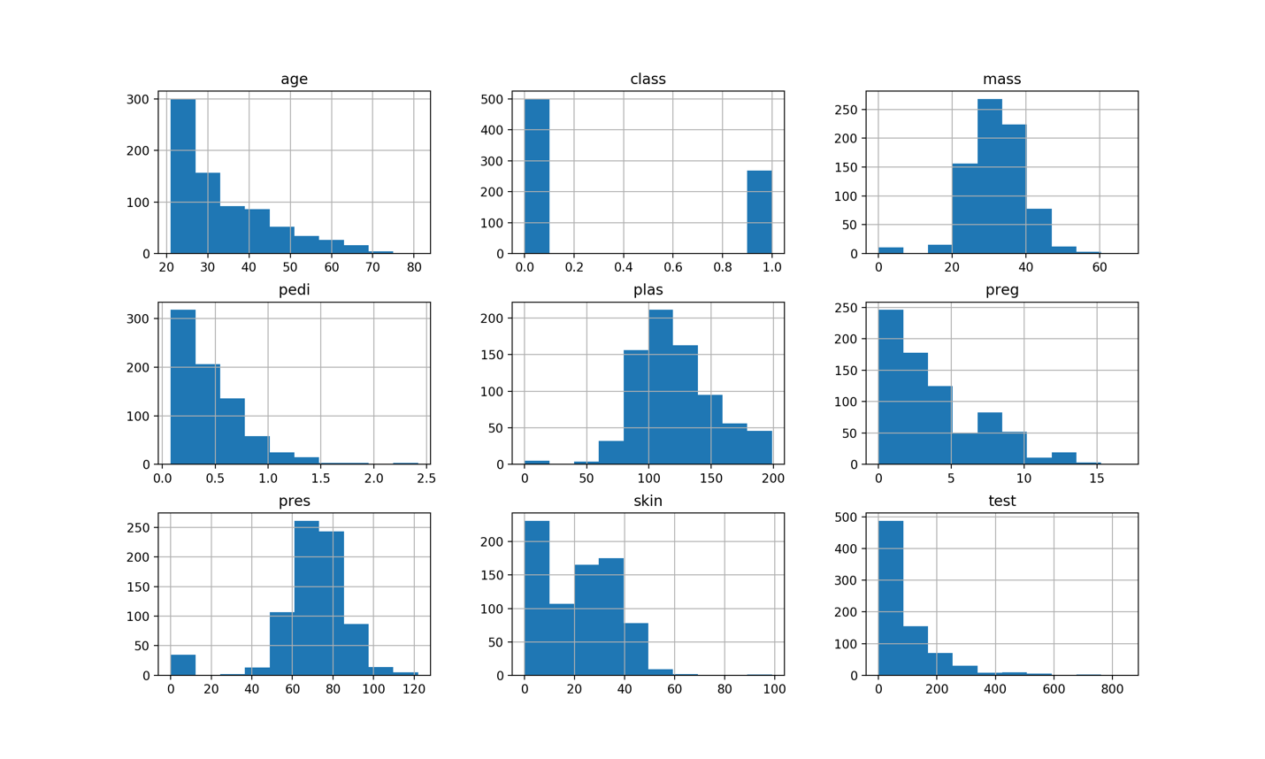

|  |
| --- |
|  |

**Tugas Pandas dan visualisasi dapat dilihat di http://kuliah.itera.ac.id**